About this Document
Applies to Chronolator Version | 3.4, 3.5
Document version | 3.5.01
Purpose | Chronolator works by running macros in the background. This document explains how to run macros in Word 2007 and earlier versions

File Format - .docm and .doc
By default, Chronolator uses the .docm format introduced by Word 2007. Earlier Word versions can read and write .docm files if the Microsoft Word Compatibility Pack is installed, but Word 2000 and Word 2002 (XP) cannot run the macros Chronolator requires in a .docm document even if the Compatibility Pack is installed.
If you need to use a Chronolator Document on Word 2000 or on Word XP, or on Word 2003 without the Compatibility Pack, you should ask whoever sent it to you to send you a version in the old .doc format.

Digitally Signed macros
Chronolator Version 3.4 and later macros are 'digitally signed' by Berrick Computing Ltd, which means that Word checks they have not been tampered with since they were published: and that if they have been, Word will not allow them to run.
You can choose to trust all documents signed by Berrick Computing Ltd, in which case Chronolator Documents will always run macros when you open them. This document shows you how.

What if I can't enable macros?
If you cannot enable macros by following the instructions below, you can still update the document but you will not be able to use basic Word Save (you will get a message about macros being disabled). In that case, you should save your changes either:
- by using Save As, or
- by closing the document and making the relevant reply when Word asks you if you want to save changes.

Enabling macros – Word 2000, XP, and 2003
How to enable macros depends on your Word Macro Security settings. These can be set to Low, Medium, High, or Very High (the last one only being available in Word 2003). The following paragraphs show you what will happen in each case, and what you need to do.

Macro Security setting 'Low'
If your Macro Security setting is Low, you do not need to take any action for macros to run. We would recommend, however, that you set it to Medium or High in order to protect yourself from viruses in other documents. You can see how to do so below, in the section Macro Security setting 'Very High'.

Macro Security setting 'Medium'
If your Macro Security setting is Medium, Word will show you this message:
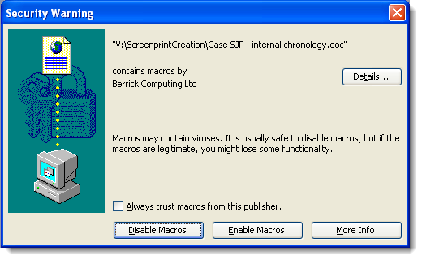
Press Enable Macros. If you don't want to do this every time you open the document, tick Always trust macros from this publisher before you press it.

Macro Security setting 'High'
If your Macro Security setting is High, Word will show you this message:
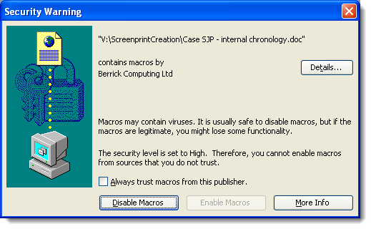
Tick Always trust macros from this publisher, and then press Enable Macros.

Macro Security setting 'Very High'
If your Macro Security setting is Very High, Word will show you this message:
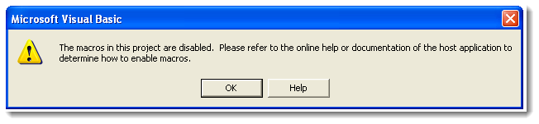
You will need to change your Macro Security settings as follows.
Press Tools > Macro > Security.  If you cannot see Macro, press the double arrow at the bottom of the Tools menu. | 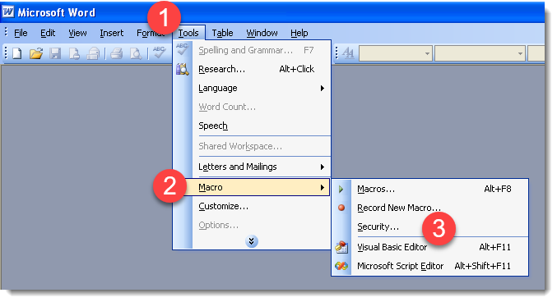
On the Security Level tab, set the level to High.  Press OK. | 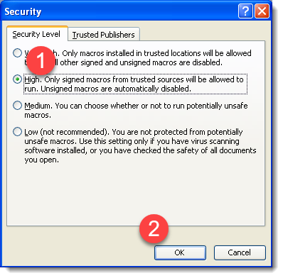

The change will not take effect until the next time you start Word.
Close ALL Word documents.
Because the settings are not changed until Word restarts, you might confusingly get the message you started with while closing the documents. Just press OK.
Open the Chronolator document again, and follow the instructions above for Macro Security Setting 'High'.

Enabling macros – Word 2007
Unfortunately, in Word 2007 Microsoft dropped support for the digital signatures Chronolator uses (they reinstated it from Word 2010 onwards).
You will need to update the 'Trust Center' in Word Options in one of two ways:
- Option 1 (not recommended) allow all macros to run;
- Option 2 (recommended) define a 'Trusted Location' in which to save your Chronolator Documents. Once they are in there, you will not need to take any action to enable macros when you open them.
Whichever options you choose, you start by opening the 'Trust Center'.

Open the 'Trust Center'
Press the button in the top left corner of the display and then press Word Options. | 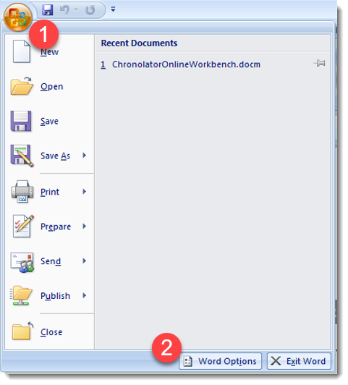
Press Trust Center, then press Trust Center Settings. | 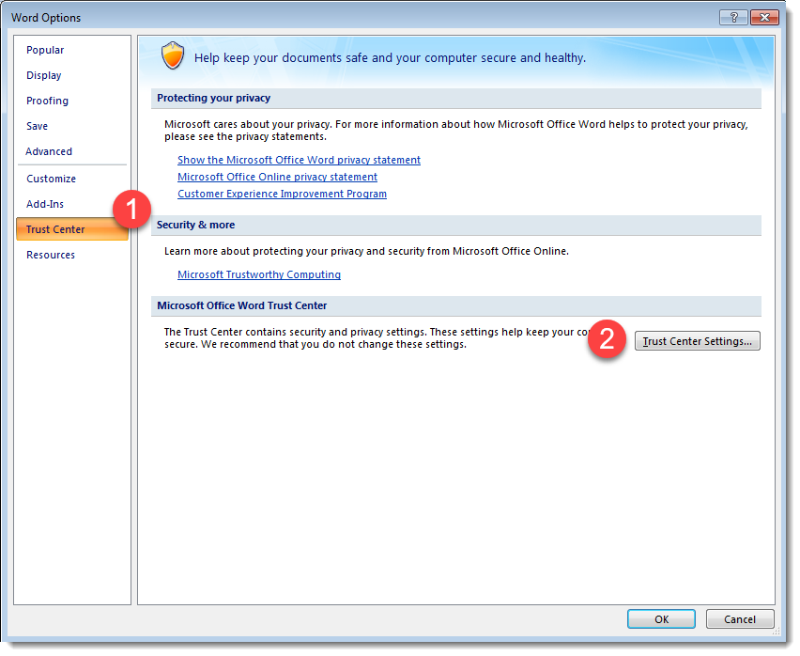

Change the 'Trust Center' Settings

Option 1 (not recommended)
This method is not recommended because it leaves you open to viruses from other documents.
Press Macro Settings  Check Enable all macros …  Press OK | 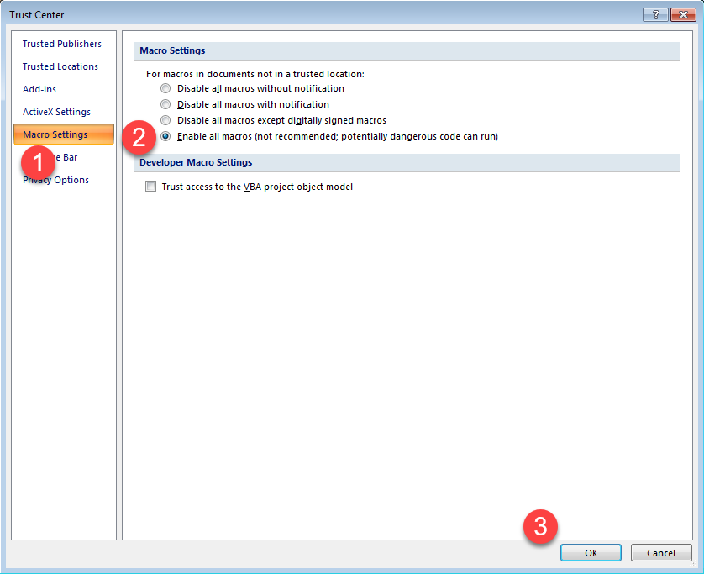
Press OK a few times until you return to Word.
Close and reopen the Chronolator document.

Option 2 (recommended)

If you do not already have one, create a folder where you will store your Chronolator Documents.  In this example, we have a folder called ChronolatorDocs in our Documents folder. | 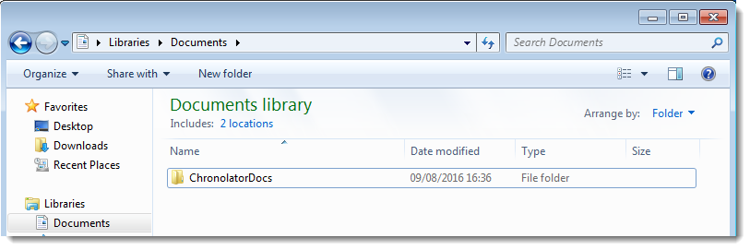
In the Trust Center Settings., press Trusted Locations … and press Add new location … | 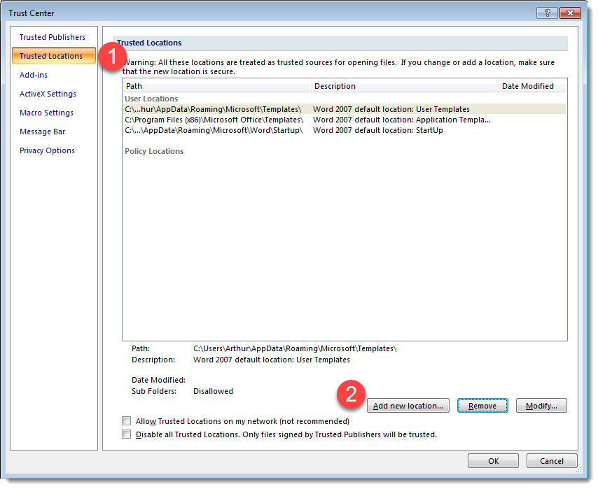
Press Browse | 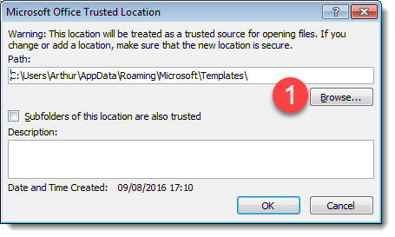
Navigate to the correct folder and press OK | 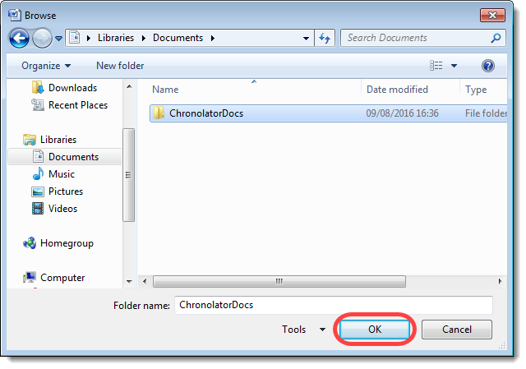
Press OK  If you want to use subfolders of this one, tick the Subfolders of this location … box.  Press OK a few times until you return to Word. | 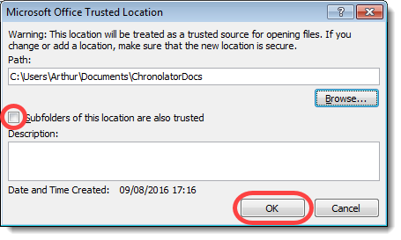
Close the Chronolator document.
Use Windows to move the document to your Trusted Location.
Open the document in your Trusted Location.

